SST AND CRE – 2015
NAME:………………………………………………….. CONTACT:…………………….

1. Give the weather condition for temperature.
____________________________________________________________
2. Which people helped Uganda to become a nation?
____________________________________________________________
3. Which side of the road is used by pedestrians?
____________________________________________________________
4. Which line of Longitude is used to determine dates?
____________________________________________________________
5. Write CCEDU in full.
____________________________________________________________
6. What are social services?
____________________________________________________________
7. Apart from Lake Katwe, write any other creator lake in Uganda.
____________________________________________________________
8. Give one way floods have been controlled on R.Nile.
____________________________________________________________
9. How does land mass influence the climate of an area.
____________________________________________________________
10. Draw a map symbol for a mine.

____________________________________________________________
11. Give one element of vegetation.
____________________________________________________________
12. Give one reason why children should be given their rights.
____________________________________________________________
13. Which compass direction lies between Southwest and West?
____________________________________________________________
14. Why was the Lando enclave transferred away from Uganda?
____________________________________________________________
15. Write the first line of the second stanza of the Uganda National Anthem.
____________________________________________________________
16. Give one cause of Re-run in democracy.
____________________________________________________________
17. What is vegetation?
____________________________________________________________
18. Give the importance of people as economic resources.
____________________________________________________________
Use the map below to answer questions 19-21.
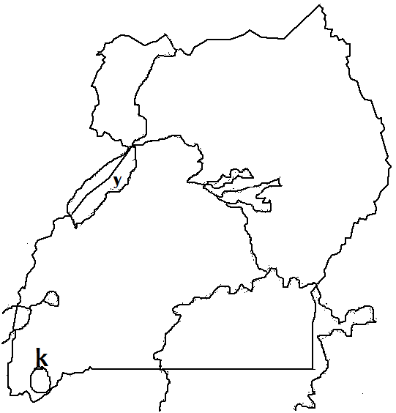

y

19. Name the game park marked K.
____________________________________________________________
20. Which river is marked Y?
____________________________________________________________
21. Use letter W to show the location of L.Wamala.
____________________________________________________________
22. Name one tribal group found in West Africa.
____________________________________________________________
23. Which type of relationship do children get from schools?
____________________________________________________________
24. Who introduced the use of a compass during travelling?
____________________________________________________________
25. What is a protectorate?
____________________________________________________________
26. How did education help the African Nationalists to fight for independence?
____________________________________________________________
27. How were the people of East Africa society organized during the Pre-colonial time?
____________________________________________________________
28. What are electoral colleges?
____________________________________________________________
29. Who named Cape Town Cape of Good hope?
____________________________________________________________
30. Which ministry in Uganda is responsible for elections?
____________________________________________________________
31. Apart from Mt. Rwenzori write any one other block Mountain in East Africa.
____________________________________________________________
32. What is a Republic?
____________________________________________________________
33. Which political party led Burundi to Independence?
____________________________________________________________
34. Give one reason why animals live in different vegetation zones.
____________________________________________________________
35. Give one factor of climate.
____________________________________________________________
36. How many people were saved by the ark during Noah’s time?
____________________________________________________________
37. Who cheated his brother in the Bible?
____________________________________________________________
38. Name the first commandment.
____________________________________________________________
39. Who was the first King of the Israelites?
____________________________________________________________
40. Name the last Miracle performed by Jesus.
____________________________________________________________

SECTION B
41. a) What are traditional industries?
____________________________________________________________
b) Give one example of traditional industries.
____________________________________________________________
c) Give two reasons why most African countries export unprocessed goods.
i) ____________________________________________________________
ii) ____________________________________________________________
42. a) Which organ of the government makes the budget?
____________________________________________________________
b) Give two reasons why most African countries run deficit budgets.
i) ____________________________________________________________
ii) ____________________________________________________________
c) Mention one part of a budget.
____________________________________________________________
43. a) State one contribution made by each of the Pan Africanists below;
i) William Dubois
____________________________________________________________

ii) Edward Blyden
____________________________________________________________
b) Give two methods the Pan Africanists used to fight for Africa’s
Independence.
i) ____________________________________________________________
ii) ____________________________________________________________
44. a) Which type of rainfall is received in Central E. Africa?
____________________________________________________________
b) Give one reason why the type of rainfall mentioned above is received in that area.
____________________________________________________________
c) Write two characteristics of the rainfall stated in 44 (a) above.
i) ____________________________________________________________
ii) ____________________________________________________________
45. a) Mention any two weather disasters.
i) ____________________________________________________________
ii) ____________________________________________________________
b) State two ways how people manage the above weather disasters?
i) ____________________________________________________________
ii) ____________________________________________________________
46.a) What is child labour?
____________________________________________________________
b) Give any two causes of child abuse.
i) ____________________________________________________________
ii) ____________________________________________________________
c) State one danger of child labour.
____________________________________________________________

47. a) Give three reasons why traders came to Africa.
i) ____________________________________________________________
ii) ____________________________________________________________
iii) ____________________________________________________________
b) In which country did the pertain traders originate?
____________________________________________________________
48. Write one tribe under each ethnic group below.
a) Bantu in Kenya
____________________________________________________________
b) Highland Nilotes in Uganda
____________________________________________________________
c) Semites
____________________________________________________________
d) River Lake Nilotes
____________________________________________________________
49. Give any four characteristics of good instructional materials used in teaching and learning of SST.
i) ____________________________________________________________
ii) ____________________________________________________________
iii) ____________________________________________________________
iv) ____________________________________________________________
50.a) Give two examples of manipulative skills developed during the teaching and learning of SST.
i) ____________________________________________________________
ii) ____________________________________________________________
b) State any two attitudes children should develop after covering some topics in SST.
i) ____________________________________________________________
ii) ____________________________________________________________
51. “Woman why are you crying?” They asked her, she answered. They have
taken my Lord away. John 20:13.
a) Which woman was being asked?
____________________________________________________________
b) Who asked the woman?
____________________________________________________________
c) Who was the Lord being talked about?
____________________________________________________________
d) What had happened to the Lord?
____________________________________________________________
52. a) Give the reason why marriage is called a social institution.
____________________________________________________________
b) Give any one characteristic of a religious marriage.
____________________________________________________________
c) What do the following signify during marriage?
i) A ring
____________________________________________________________
ii) White clothes for the bride.
____________________________________________________________
53. a) Give two symbols of the Holy Spirit.
i) ____________________________________________________________
ii) ____________________________________________________________
b) State two ways how the Holy Spirit is important to the church?
i) ____________________________________________________________
ii) ____________________________________________________________
54. a) What did God create on the days below?
i) 1st day
____________________________________________________________
ii) 2nd day
____________________________________________________________
b) Give two reasons why God created man last?
i) ____________________________________________________________
ii) ____________________________________________________________
55. a) Which day marks the beginning of the Holy week?
____________________________________________________________
b) Mention nay two things that happened in the Holy week?
i) ____________________________________________________________
ii) ____________________________________________________________
c) As Christians, what do we learn from the Holy week?
____________________________________________________________

